PROJECT BASED LAB REPORT
On
GODOWN STOCK MANAGEMENT SYSTEM
Submitted in partial fulfilment of the
Requirements for the award of the Degree of
Bachelor of Technology
in
ELECTRONICS AND COMMUNICATION ENGINEERING
By
ROHINI PANDIRI 2100031934



DEPARTMENT OF ELECTRONICS AND COMMUNICATION ENGINEERING

K L University
Green Fields, Vaddeswaram, Guntur District-522 502
2016-2017

K L University
DEPARTMENT OF ELECTRONICS AND COMMUNICATION ENGINEERING

CERTIFICATE

This is to certify that this project based lab report entitled ”GODOWN WAREHOUSE STOCK MANAGEMNT SYTEM” is a bonafide work done by ROHINI PANDIRI 2100031934 in partial fulfilment of the requirements for the award of degree in BACHELOR OF TECHNOLOGY in ELECTRONICS AND COMMUNICATION ENGINEERING during the Academic year 2021-2022.

Faculty in Charge Head of the Department
Smt P.S.G.Aruna Sri Dr.A.S.C.S.SASTRY
K L University
DEPARTMENT ELECTRONICS AND COMMUNICATION ENGINEERING

DECLARATION

We hereby declare that this project based lab report titled “GODOWN WAREHOUSE STOCK MANAGEMENT SYSTEM” has been prepared by us in partial fulfilment of the requirements for the award of degree “BACHELOR OF TECHNOLOGY in ELECTRONICS AND COMMUNICATION ENGNEERING” during the Academic year 2016-2017.
We also declare that this project based lab report is of our own efforts and it has not been submitted to any other university for the award of any degree.

ROHINI PANDIRI 2100031934

ACKNOWLEDGEMENT

Our sincere thanks to Smt P.S.G. Aruna Sri in the Lab for their outstanding support through out the project for the successful completion of the work.
We express our gratitude to DR.A.S.C.S.SASTRY, Head of the Department for Electronics and communication Engineering for providing us with adequate facilities, ways and means by which we are able to complete this project based Lab.
We would like to place on record the deep sense of gratitude to the honourable Vice Chancellor, K L University for providing the necessary facilities to carry the project based Lab.
Last, but not the least, we thank all Teaching and Non-Teaching Staff of our department and especially my classmates and my friends for their support in the completion of our project based Lab.

ROHINI PANDIRI 2100031934

CONTENTS
- Abstract ………………….. 6
- Introduction .............................. 7
- Module description ………………….. 8
- Algorithm ………………….. 9
- Source code of project ............................. 11
6. Screen shots of the output …………………. 23
- conclusion and future scope ............................. 29
- Bibilography and References ............................. 30

GODOWN STOCK MANAGEMENT SYSTEM

ABSTRACT:
Godown Stock Management System is a web-based application developed using Java programming language. The main objective of this project is to manage a stock and take care of sales and purchase of products. The existing Stock Management procedure is a manual one which run with pen and paper. It is very time consuming. To overcome the drawbacks and limitations of the existing system, this Stock Management System software is proposed. The main goal of godown stock Management System is to ensure consistent availability of supplies for consumers. Thus, godown stock Management System is directed toward owners of small to large stores and stock managers who are responsible of maintaining sufficient goods on hand in a retail or manufacturing business. It can scale from a single computer running both client and server software up to multiple stores and warehouses.The system is also capable of tracking In & Out transaction of single or multiple stores as well as also generates their billing details.

INTRODUCTION

A Godown management system is a software application, designed to support warehouse or distribution center management and staff. They facilitate management in their daily planning, organizing, staffing, directing, and controlling the utilization of available resources, to move and store materials into, within, and out of a godown, while supporting staff in the performance of material movement and storage in and around a warehouse.
The evolution of godown management systems is very similar to that of many other software solutions. Initially a system to control movement and storage of materials within a warehouse, the role of godown management system is expanding to including light manufacturing, transportation management, order management, and complete accounting systems. The primary purpose of a Godown management system is to control the movement and storage of materials within an operation and process the associated transactions. Directed picking, directed replenishment, and directed put away are the key to Godown management system. The detailed setup and processing within a Godown management system can vary significantly from one software vendor to another, however the basic logic will use a combination of item, location, quantity, unit of measure, and order information to determine where to stock, where to pick, and in what sequence to perform these operations.

Warehouse management solution are primarily tactical tools, purchased and used by businesses to satisfy the unique customer demand requirements of their supply chain and distribution channel, when the inventory and workload are larger than can be handled manually, with spreadsheets. Motivation to purchase generally comes from need to support sales growth or improve performance, and occasionally both.

3. MODULE DESCRIPTION
AIM: - To write the JAVA code for the following program
- GODOWN DETAILS.
- STOCK DETAILS AND CALCULATING THE BILL AMOUNT OF PURCHASE.
- CUSTOMER DETAILS.
3.1 DESCRIPTION OF MODULES
3.1.1.MODULE 1:
In the first module we need to enter the details of the Godown (that includes Godown Name, Licence number, Godown Capacity, Area which it is located, City, Pincode).

3.1.2. MODULE 2:
In second module we need to enter the details of the Stocks(which includes some items like Groundnuts, Cotton, Tiles, Wheat Grains etc...), Number of Items placed, Price of the Items, etc . module we need to calculate the total bill amount of the purchased stock items offered by the customer and display the stock purchased by the customer.
3.1.3.MODULE 3:
In third module we need to enter the details of the Customer who wish to purchase the Stock in the Godown. Here we will be creating bills information with details like customer name , bill number and bill. Here each and every record has to be entered manually through keyboard, where it asks the user to save how many records he need to enter in files. After entering those records through proper format those details which user gives can be saved.
In this module we will be able to update the details of customer through the records which are present in the form of name. Here we can able to see those present in files, where we can search those details through bill number. Here in this module formatter file takes control of all the things for searching the complete details of customer. Here in generating reports we will be able to display all the details of customer bills.

4.ALOGIRTHM
1.start
2.Display system banner(i.e;WELCOME TO GODOWN STOCK MANAGEMENT SYSTEM// static block).
3. the program will display menu with different options
4.if we select first option then program will give options to enter godown details, take new godown details (i.e;display godown name,city ,license number,address,capacit)and exit
5.It will diaplay
5.1 enter godown details into files
5.2 view godown details on the screen.
5.3 exit
6. display “enter stock details”
7.switch(c)
7.1. display ground nuts
7.2. display wheat grains
7.3. display cotton
7.4. display rice bags
7.5. display tiles
8. display avalabity of the items
9. display items you have requested
10.display cost of the item per bag
11. display total bill amount of stock purchased
12.display “enter customer details “
13.display “enter customer namme, id no, phone number address of the customer”
switch(c)
13.1 enter customer details into files
13.2 view customer details on the screen.
  - exit
14.create a main class object
15.call all the method of other class
16.If there is any errors like input mismatch , file opening problem and file not found exception they will displayed and asked for a correct input.

17.Then the user can exit from the program.

18.end.

5.SOURCE CODE OF THE PROJECT
MODULE :1
package godownmanagement;
import java.io.*;
import java.util.Scanner;
interface Class{
void display();
}

public class Details implements Class{
Details(){
// default constructor
}
//paramatized constructor
//Details(String name,String licenseno,int capacity,String city,int pincode,String address)
//{
//this.name=name;
//this.licenseno=licenseno;
//this.capacity=capacity;
//this.city=city;
//this.pincode=pincode;
//this.address=address;
//}
/*----------------------------------------------------------
display() - method of interface implemented
simple exception handling is implemented
data entry and validation is done
----------------------------------------------------------*/
public void display(){
int k;
Scanner in=new Scanner(System.in);
System.out.println(" 1. enter Godown details");
System.out.println(" 2. view Godown details details");
System.out.println(" 3. for exit");
System.out.print(" Enter your choice:");
k=in.nextInt();
switch(k){
case 1: try {
int i,n;
String name;
String city;
String licenseno;
int pincode;
String address;
int capacity;
File file = new File("det.txt");

// if file doesnt exists, then create it
if (!file.exists()) {
file.createNewFile();
}
System.out.print("Enter no.of godown details value: ");
n=in.nextInt();

FileWriter fw = new FileWriter(file.getAbsoluteFile());
BufferedWriter bw = new BufferedWriter(fw);
for (i=0;i<n;i++){
System.out.print("Enter name of Godown: ");
name=in.next();
System.out.print("Enter City: ");
city=in.next();
System.out.print("Enter license number:");
licenseno=in.next();
System.out.print("Enter pincode number: ");
pincode=in.nextInt();
System.out.print("Enter address :");
address=in.next();
System.out.print("Enter capacity :");
capacity=in.nextInt();
bw.write(name+" ");
bw.write(city+" ");
bw.write(licenseno+" ");
bw.write(pincode+" ");
bw.write(address+" ");
bw.write(capacity+"");
bw.newLine();
System.out.println("Done");
}
bw.close();

} catch (IOException e) {
e.printStackTrace();
}
break;
case 2: try{

File file = new File("det.txt");

String name;
String city;
String licenseno;
int pincode;
String address;
int capacity;
Scanner input=new Scanner(file);
// Read each line until end of file is reached
while(input.hasNext()) {
name=input.next();
city=input.next();
licenseno=input.next();
pincode=input.nextInt();
address=input.next();
capacity=input.nextInt();
System.out.println(name+ " "+capacity+" "+city+ " "+licenseno+" "+pincode+" "+address );
}
}catch(FileNotFoundException fnf){
System.out.println(fnf);
System.out.println(" pl. provide me the file");
}
break;
case 3: System.exit(0);

default: System.out.print("Enter only 1 or 2 or 3\n");
}}

}

MODULE:2
package godownmanagement;
import java.io.*;
import java.util.Scanner;
public class Stockdetails implements Class{
public void display(){

try {
int i,k=100,z,p,n;
int c;
int amount=0;
String itemname;
File file = new File("stk.txt");

// if file doesnt exists, then create it
if (!file.exists()) {
file.createNewFile();
}
Scanner in=new Scanner(System.in);

System.out.println(" select the stock item");
System.out.println("********************************************************************");
System.out.println(" details of stock items are mentioned below");
System.out.println(" \n1.Ground nuts \n2.wheat grains\n 3.cotton \n4.rice bags\n 5.tiles\n");

System.out.print("enter ur choice");
c=in.nextInt();
System.out.print("enter no of items you needed");
p=in.nextInt();

switch(c)
{
case 1:{
System.out.print("avalabity of the items are\n "+k);

System.out.print("\nitems you have requested are\n"+p);
System.out.print("\ncost of the item is 200 per bag\n");
amount=p*200;
System.out.print("\ntotal bill amount of stock purchased ==\n"+amount);
break;
}
case 2:{
System.out.print("\navalabity of the items are\n"+k);
System.out.print("\nitems you have requested are\n"+p);
System.out.print("\ncost of the item is 300 per bag\n");
amount=p*300;
System.out.print("\ntotal bill amount of stock purchased ==\n"+amount);
break;

}
case 3:{ System.out.print("\navalabity of the items are\n"+k);
System.out.print("\nitems you have requested are\n"+p);
System.out.print("\ncost of the item is 400 per bag\n");
amount=p*400;
System.out.print("\ntotal bill amount of stock purchased ==\n"+amount);
break;
}
case 4:{ System.out.print("\navalabity of the items are\n"+k);
System.out.print("\nitems you have requested are\n"+p);
System.out.print("\ncost of the item is 500 per bag\n");
amount=p*500;
System.out.print("\ntotal bill amount of stock purchased ==\n"+amount);
break;
}
case 5:{ System.out.print("\navalabity of the items are\n"+k);
System.out.print("\nitems you have requested are\n"+p);
System.out.print("\ncost of the item is 250 per box\n");
amount=p*250;
System.out.print("\ntotal bill amount of stock purchased ==\n"+amount);
break;
}
default:System.out.println("Enter correct number");

}

FileWriter fw = new FileWriter(file.getAbsoluteFile());
BufferedWriter bw = new BufferedWriter(fw);
System.out.print("For Updating in files please enter number of items you have requested");
System.out.print("Enter number of items ");
n=in.nextInt();
System.out.print("Enter number of items ");
z=in.nextInt();
for (i=0;i<n;i++){
System.out.print("Enter item name :");
itemname=in.next();
bw.write(itemname+" ");
bw.newLine();
System.out.println("Done");
}
bw.close();

} catch (IOException e) {
e.printStackTrace();
}
}
}
MODULE 3:
package godownmanagement;
import java.io.*;
import java.util.Scanner;
public class Customerdetails implements Class{
public void display(){
int k;
Scanner in=new Scanner(System.in);
System.out.println(" 1. registering new customer");
System.out.println(" 2. view customer data");
System.out.println(" 3. for exit");
System.out.print(" Enter your choice:");
k=in.nextInt();
switch(k){
case 1: try {
int i,n;
String name;
String id;
String phoneNo;
String address;
File file = new File("cus.txt");
// if file doesnt exists, then create it
if (!file.exists()) {
file.createNewFile();
}
System.out.print("Enter no.of customers value: ");
n=in.nextInt();
FileWriter fw = new FileWriter(file.getAbsoluteFile(),true);
BufferedWriter bw = new BufferedWriter(fw);
for (i=0;i<n;i++){
System.out.print("Enter name: ");
name=in.next();
System.out.print("Enter id: ");
id=in.next();
System.out.print("Enter phone number: ");
phoneNo=in.next();
System.out.print("Enter address :");
address=in.next();
bw.write(name+"name of godown is ");
bw.write(id+" ");
bw.write(phoneNo+" ");
bw.write(address+" ");
bw.newLine();
System.out.println("Done");
}
bw.close();
} catch (IOException e) {
e.printStackTrace();
}
break;
case 2: try{
File file = new File("cus.txt");
String name;
String id;
String phoneNo;
String address;
Scanner input=new Scanner(file);
while(input.hasNext()) {
name=input.next();
id=input.next();
phoneNo=input.next();
address=input.next();
System.out.println(name+ " "+id+ " "+phoneNo+" "+address );
}
}catch(FileNotFoundException fnf){
System.out.println(fnf);
System.out.println(" pl. provide me the file");
}
break;
case 3: System.exit(0);
default: System.out.print("Enter only 1 or 2 or 3\n");
}}

}
MAIN CLASS
package godownmanagement;
import java.io.*;
import java.util.Scanner;
public class Stock {
void go_run(){
/*---------------------------
MENU - implementation
----------------------------*/
int choice;
Scanner in=new Scanner(System.in);
while(true){
System.out.println(" MENU");
System.out.println(" ");
System.out.println(" 1. for registering GODOWN DETAILS");
System.out.println(" 2. for registering STOCK DETAILS DETAILS AND TO CALCULATE BILL AMOUNT FOR PURCHASE");
System.out.println(" 3. for registering CUSTOMER DETAILS ");
System.out.println(" 4. for exit");
System.out.print(" Enter your choice:");
choice=in.nextInt();
switch(choice){

case 1:
Details d=new Details();
d.display();
break;
case 2:
Stockdetails s=new Stockdetails();
s.display();
break;
case 3:
Customerdetails c=new Customerdetails();
c.display();
System.out.println("enter ur choice");
break;
case 4: System.exit(0);

default: System.out.print("Enter only 1 or 2 or 3 or 4\n");
//default:JOptionPane.showMessageDialog(null,"Enter 1,2 or 3 only");
}
}
}

/*----------------------------------------------------------
Static block is implemented
----------------------------------------------------------*/
static {
System.out.println("*************************************************");
System.out.println(" -----welcome to godown stock management system-----");
System.out.println("*************************************************");
}
/*------------------------------------------------
main() method- Execution actually begins here
------------------------------------------------*
public static void main(String args[]){
Stock gd=new Stock();
try {
gd.go_run();
} catch(Exception e)
{
System.out.println(" file opening problem " +e);
}
}
}

6.OUTPUT SCREEN SHOTS:

6.1.

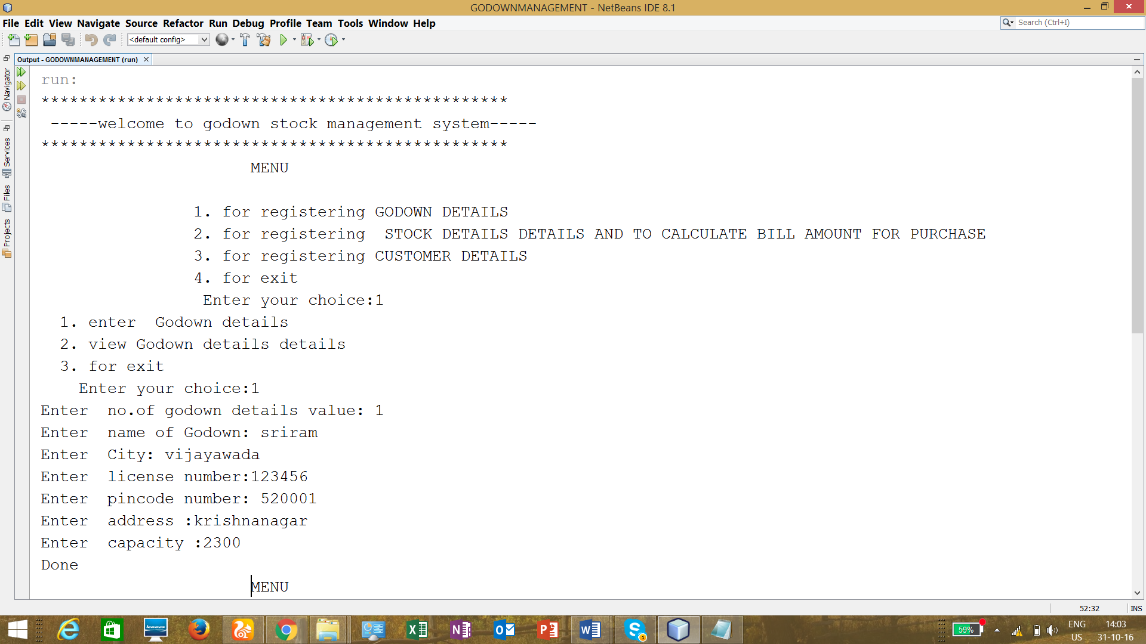

6.2.
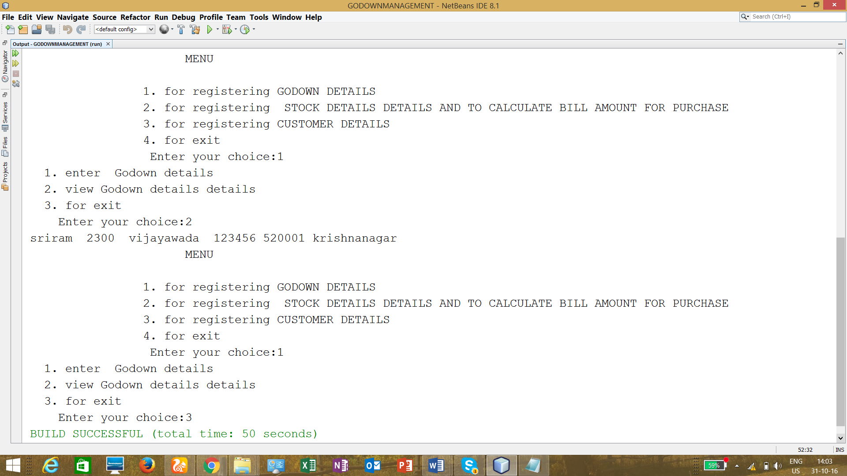

6.3.
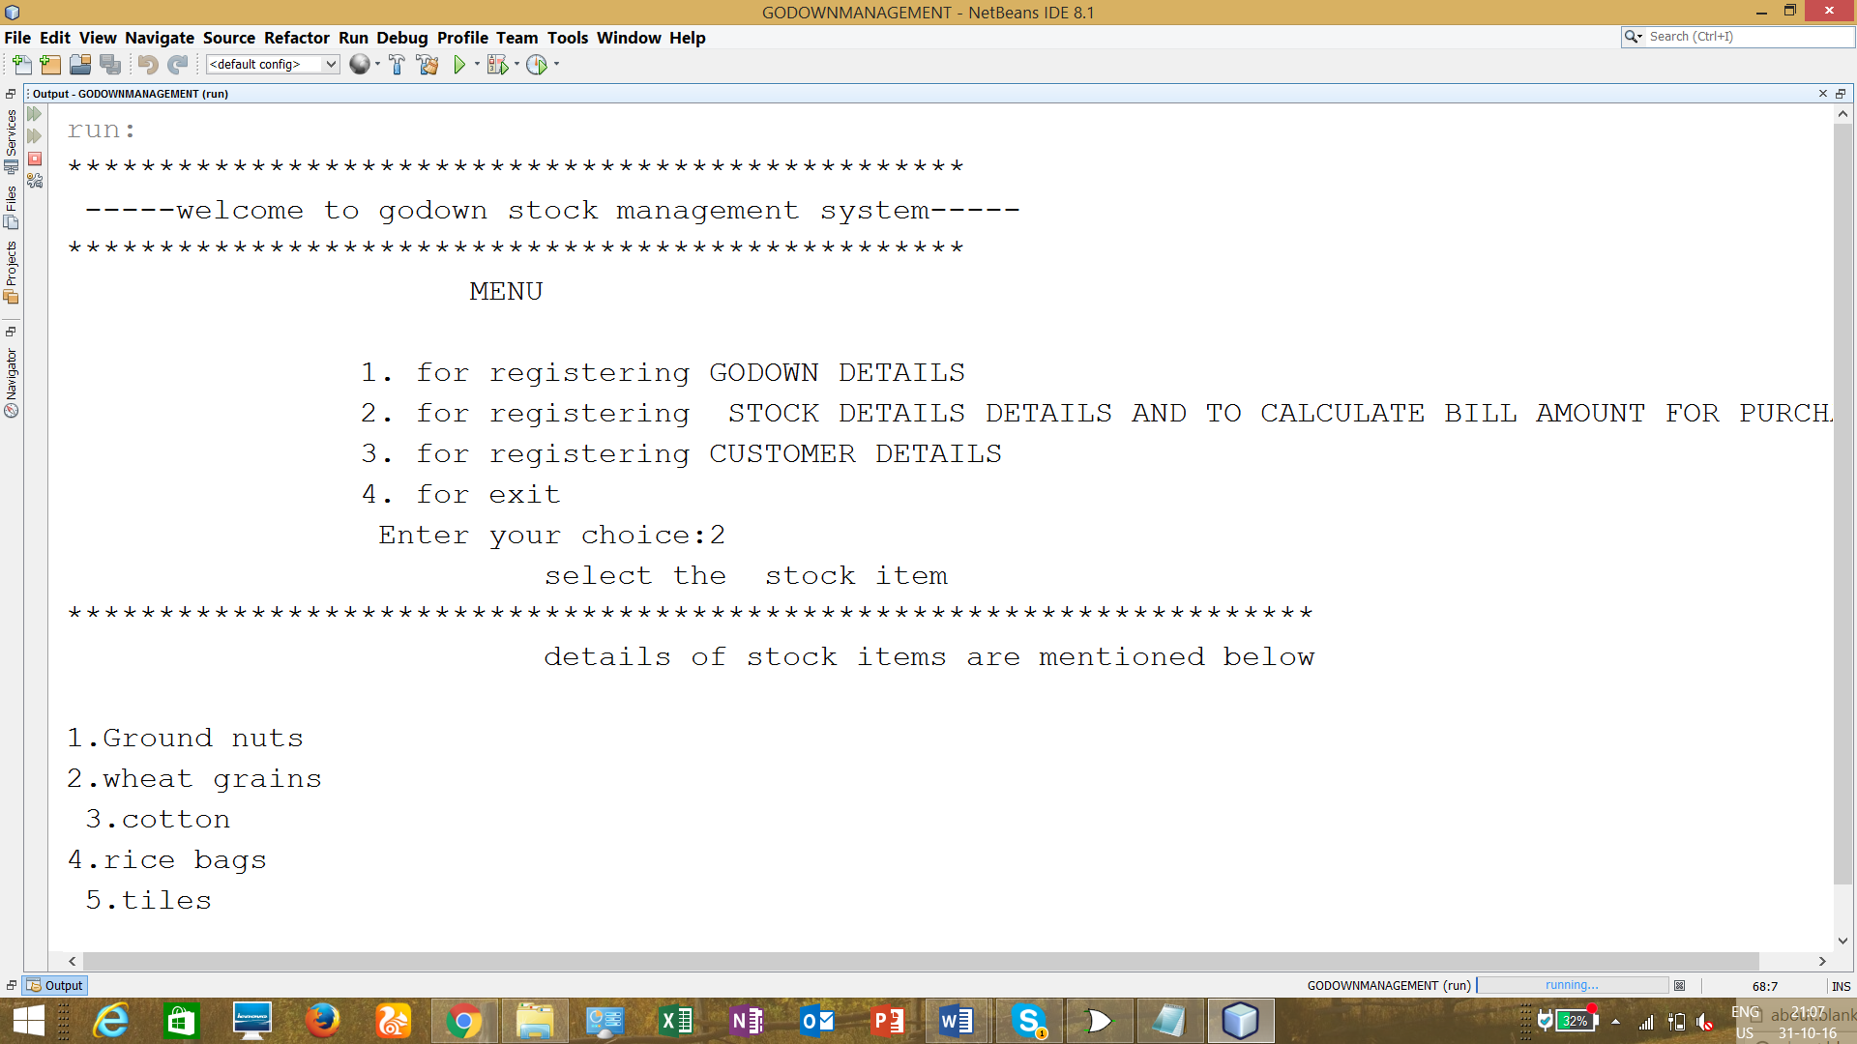

6.4.
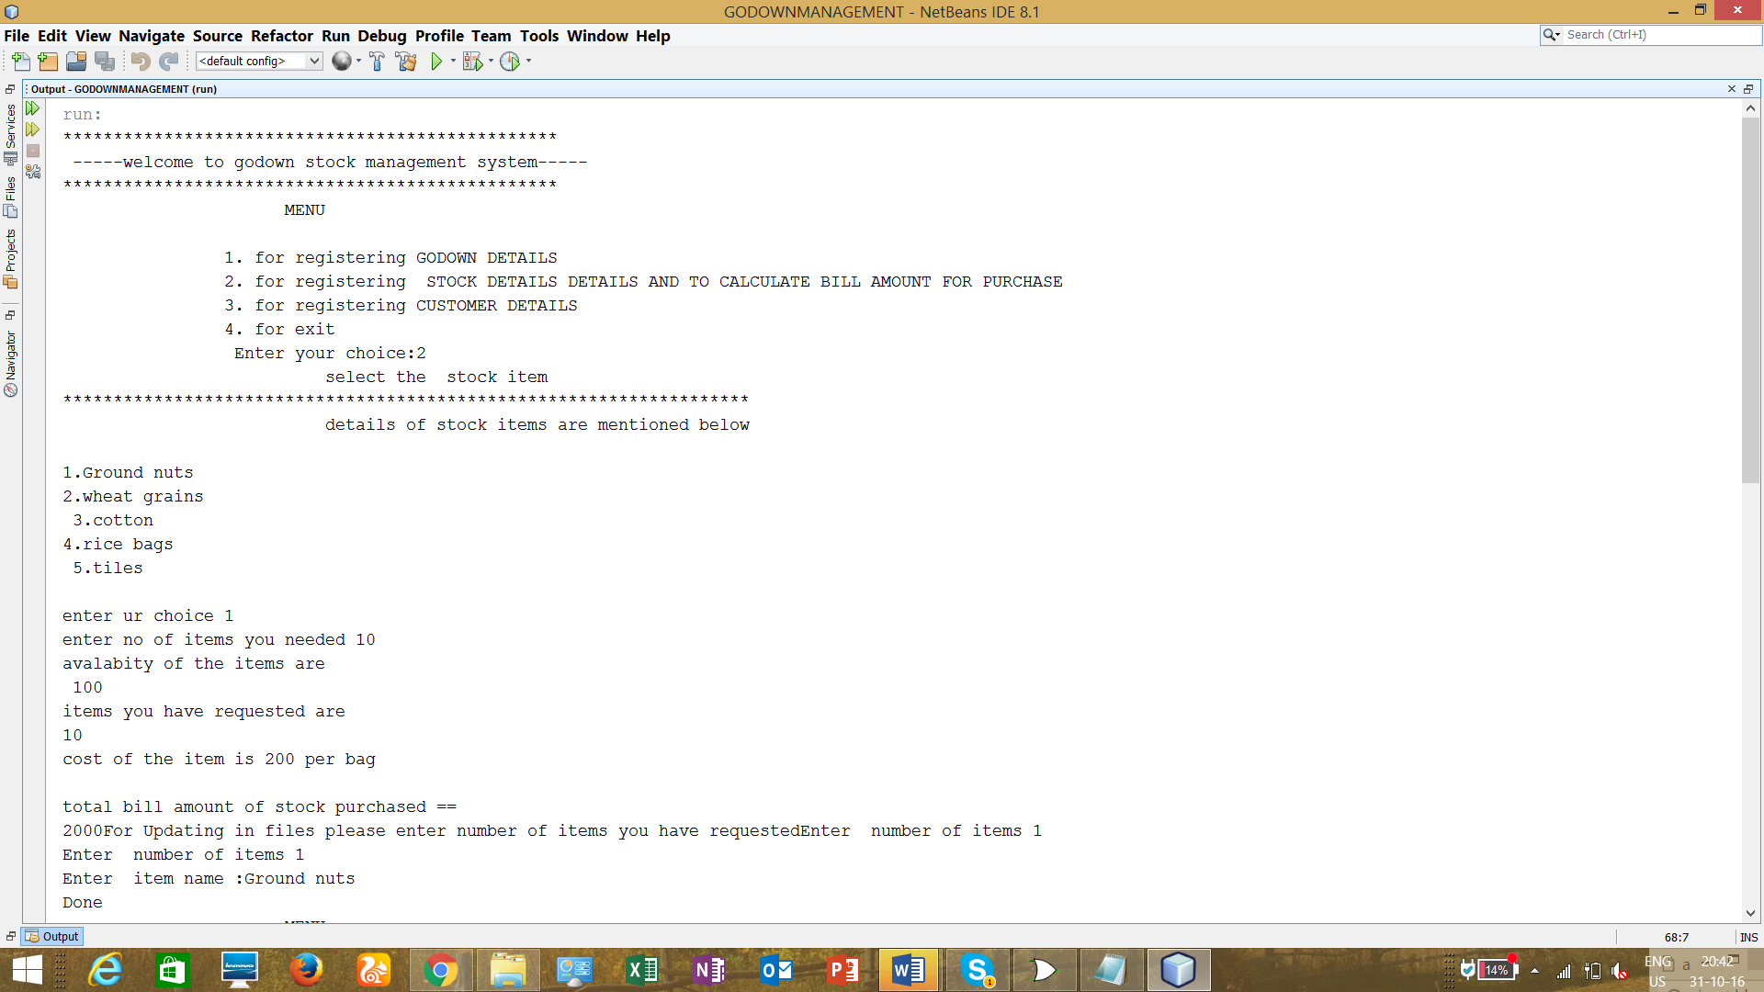

6.5.
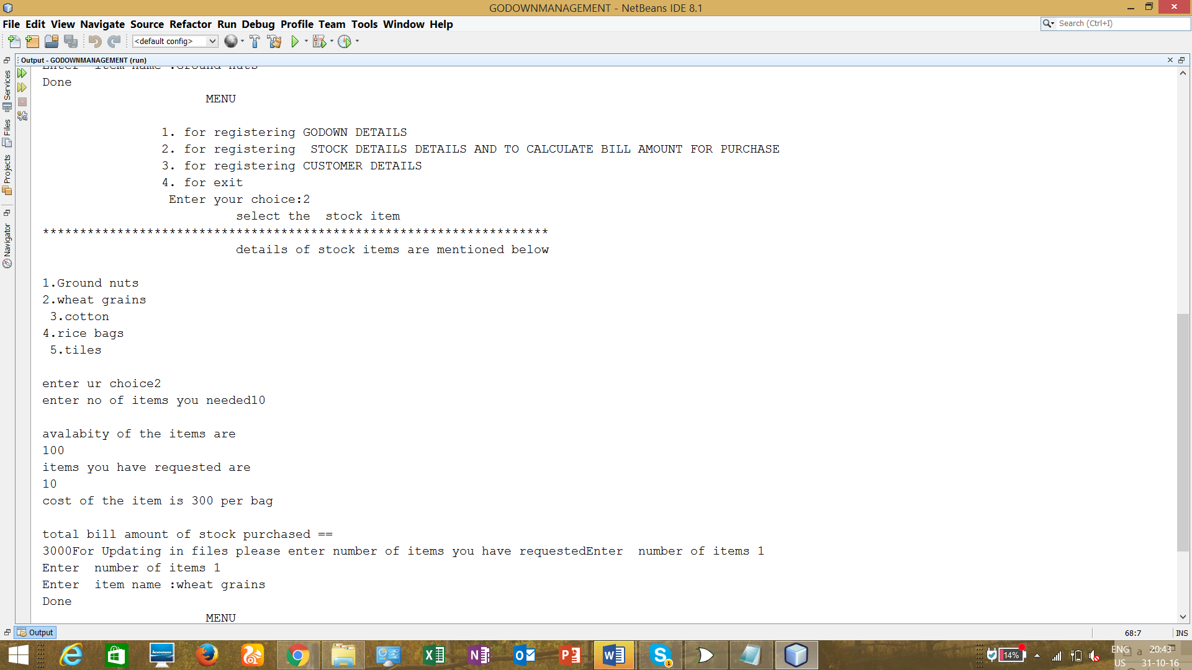

6.6.
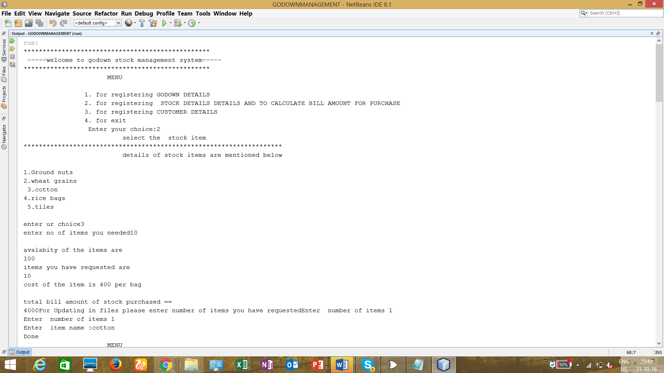
6.7.
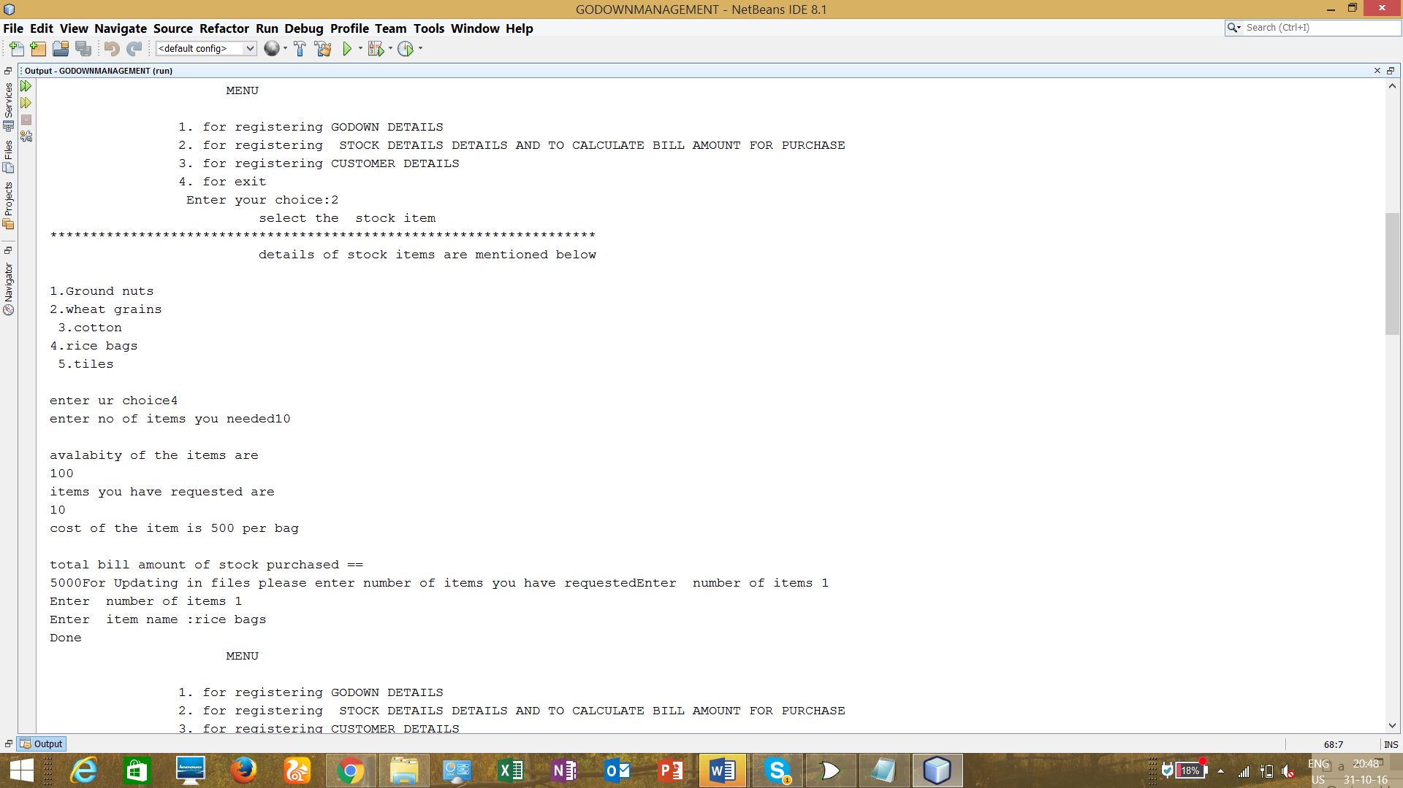
6.8
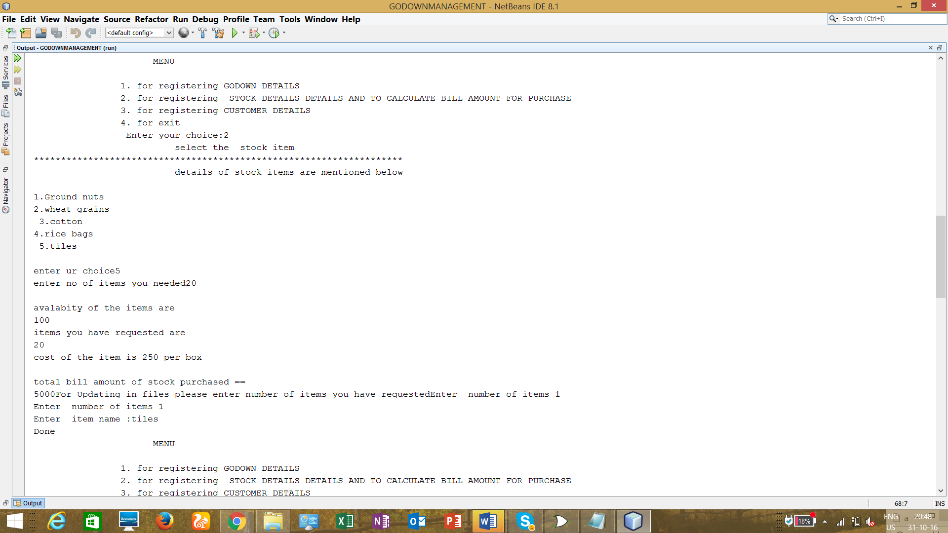
6.9.
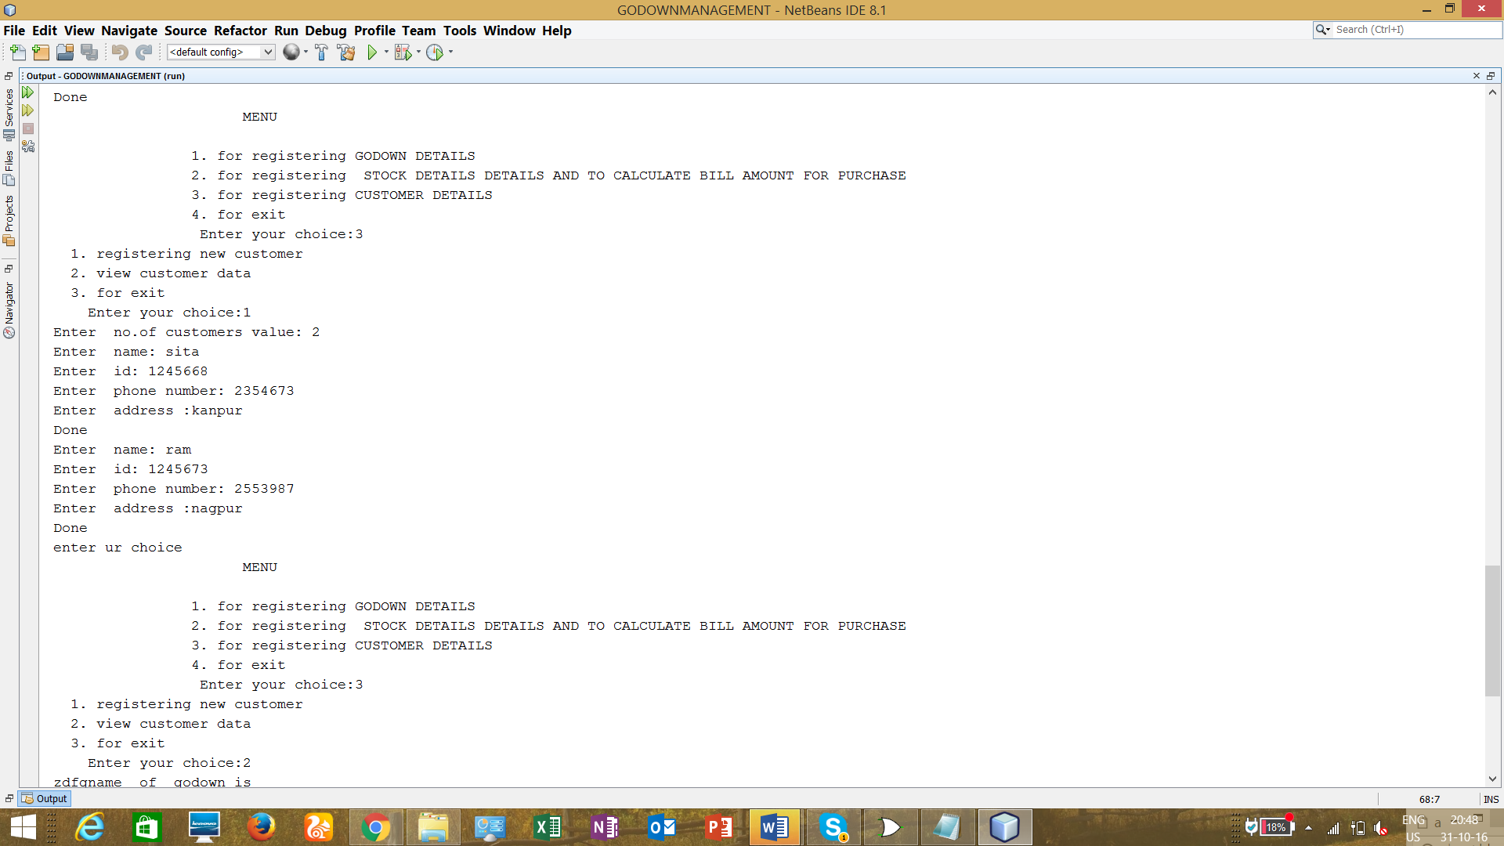6.10
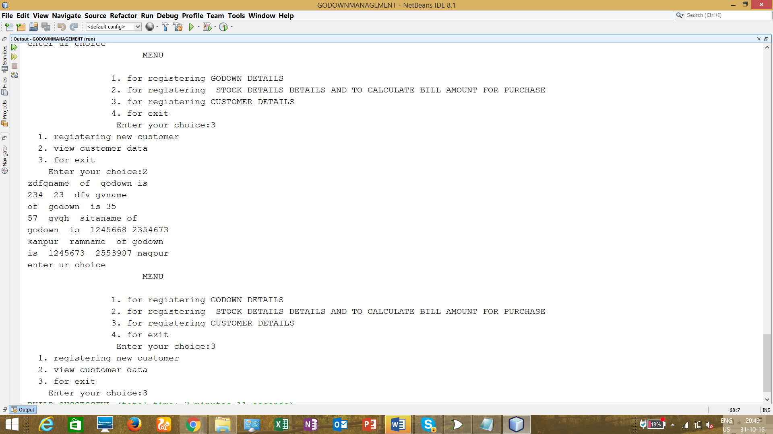

s
7. Conclusion:
Using files,interfaces,exceptional handling,packages,constructors The project is successfully completed to the extent possible. The project Godown Management System is for computerizing the working in a godown. The software takes care of all the requirements of a godown and is capable to provide easy and effective storage of information related to goods that come up to the godown.
It generates test reports provide prescription details including various tests buy,sell,order
and billing to godown. The system also provides the facility of backup as per the requirement.
Here by using the java program we have written a code which is useful and helpful to the workers in godown. It works efficiently and softly manageable to anyone.

7.1. Future Scope:
Some more functions or modules may be added to project. After studying and understanding Graphic User Interface (GUI) of java, the inputs and outputs can be improved and implemented using GUI. The project aims at providing an efficient interface to the restaurants for managing their grocery inventory based on each item sold. The basic idea involved here is that each item is linked to its atomic ingredients which are stored in a database.

8. Bibliography
- Herbert Schildt, “The Complete Reference Java2”, 5th edition TMH, 2002.

- Timothy A. Budd, “An Introduction to Object-Oriented Programming”, 3/E, Pearson, 2008.

REFERENCES:
http://www.supershareware.com/godown-management-free/
http://dlca.logcluster.org/display/LOG/Warehousing+and+Inventory+Management

